Generative AI-based Medical Chatbot Application-Final Project Submission
This document describes the design, implementation, and testing of a Generative AI-based medical chatbot developed to support clinicians in interpreting clinical text and answering natural language questions. The chatbot is implemented using a Gradio web interface and a lightweight pre-trained biomedical language model.

Task 1: Gradio Web Application Interface
A chatbot-style web interface was developed using the Gradio framework. The interface includes three clearly labeled text boxes: one for entering a medical report, one for entering a clinical question, and one for displaying the AI-generated answer. A button labeled “Get the Answer” triggers the chatbot response. The interface renders correctly with all components visible and easy to use.
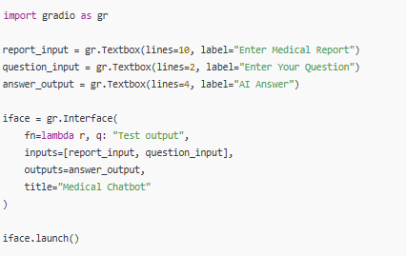
Figure 1

Task 2: Lightweight Language Model Integration
To enable natural language understanding and generation, a lightweight sequence-to-sequence language model was integrated using the Hugging Face Transformers library. The google/flan-t5-small model was selected due to its efficiency and strong performance on question-answering tasks. The model and tokenizer were loaded using AutoTokenizer and AutoModelForSeq2SeqLM, and a text2text-generation pipeline was created. A test prompt confirmed that the model generates concise and relevant medical answers.
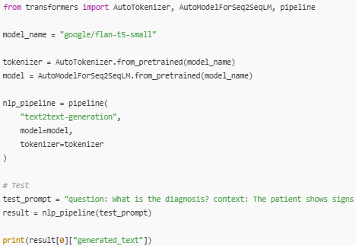
Figure 2

Task 3: Answering Function Implementation
An answering function was implemented to connect user inputs from the Gradio interface to the language model. The function accepts a medical report and a clinical question, constructs a structured prompt in the format “question: … context: …”, and generates a response using the integrated model. The function also handles missing inputs gracefully by prompting the user to provide both required fields. Testing with a sample clinical report confirmed accurate and meaningful responses.
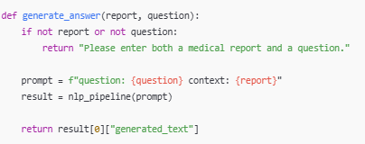
Figure 3
Medical Report:
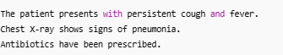
Figure 4
Question:


Task 4: Application Testing and Validation
The complete chatbot workflow was tested by entering a sample medical report and a related question into the Gradio interface. Upon clicking the “Get the Answer” button, the chatbot successfully generated a clear and clinically relevant response. This confirms that the application functions correctly from input to output and is suitable for assisting clinicians in quickly extracting key information from medical text.
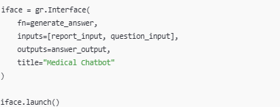
Figure 6
Overall, this project demonstrates the effective use of generative AI for clinical text interpretation through a simple, user-friendly interface. The chatbot provides reliable responses while maintaining usability and performance, making it a useful prototype for clinical decision support.

